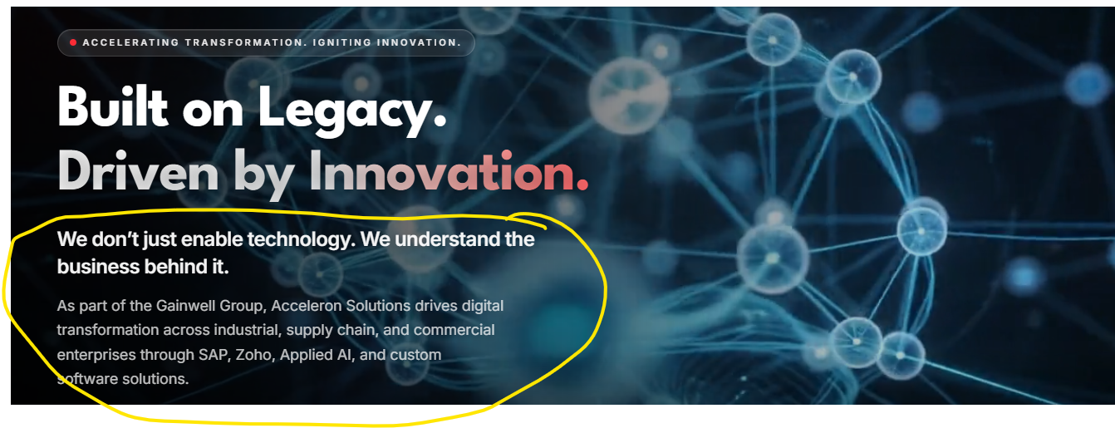
Please reduce the content:
Remove: “ We don’t just enable technology….”
Change the body text to:
Acceleron Solutions combines SAP and Zoho consulting, predictive AI and scalable custom software to solve complex operational challenges and deliver measurable business value.

Page: https://acceleron-website.vercel.app/services/sap/sap-ams
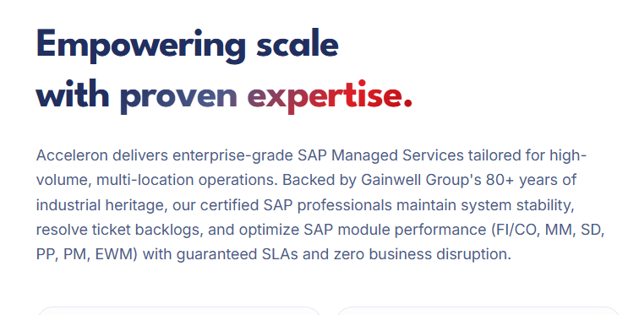

Change the body copy to:
Acceleron delivers enterprise-grade SAP Managed Services tailored for high-volume, multi-location operations. Our certified SAP professionals ensure system stability, clear ticket backlogs, and optimize SAP module performance (FI/CO, MM, SD, PP, PM, EWM), backed by defined SLAs and a commitment to uninterrupted business operations.

Page: Acceleron Solutions — Engineering Digital Excellence
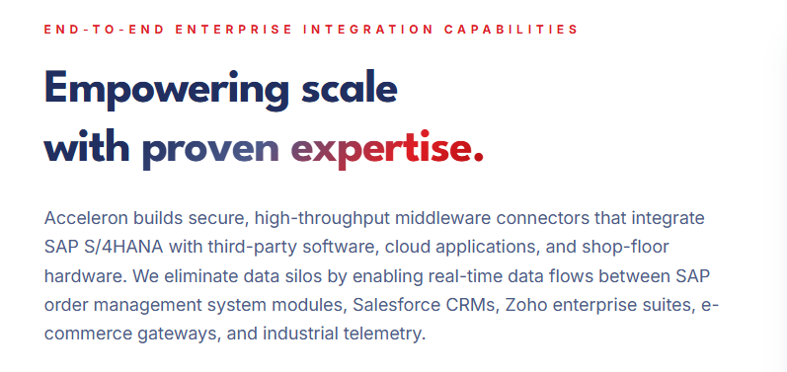
Change body text to:
Secure, high-throughput middleware connectors integrate SAP S/4HANA with third-party software, cloud applications and shop-floor hardware. Enabling real-time data exchange across SAP, Salesforce, Zoho, e-commerce platforms and industrial systems, these integrations eliminate data silos and streamline operations.
Page: https://acceleron-website.vercel.app/careers
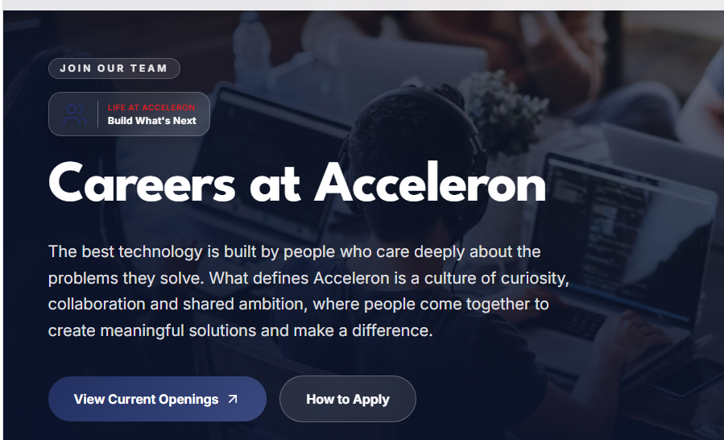
Please change body text to:
Driven by people who care deeply about solving problems, our culture thrives on curiosity and collaboration. Fostering shared ambition, we bring people together to create meaningful solutions that make a difference.
Page: https://acceleron-website.vercel.app/about
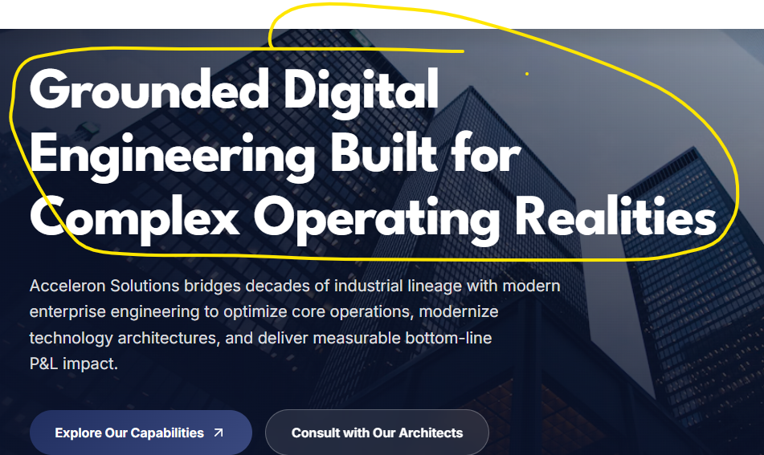
Change header to:
Digital Engineering for Complex Operations
Change body text to:
Combining decades of industrial heritage with modern enterprise engineering to optimize operations, modernize technology and deliver measurable business impact.
Page: https://acceleron-website.vercel.app/services/it-custom-solutions
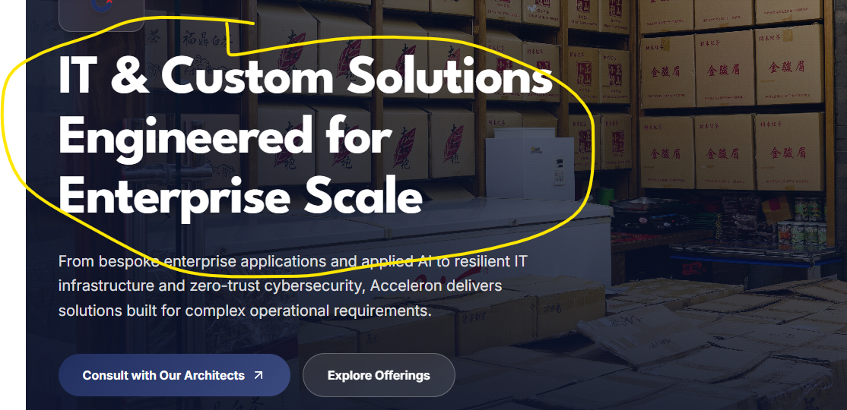

Change header to:
Custom Technology for Enterprise Needs

